|  |  |
| --- | --- |
|  |  |
| Weekly Portfolio |  |
|  |  |
|  | Responsive Web Applications |
|  | By Ashan HewagamaBSCP|CS|51|087 My GitHub link - [My Github Repository](https://github.com/ifunboi/-SIT120-RWA-Assignments.git) |

|  |  |  |  |
| --- | --- | --- | --- |
|  |  |  |  |
|  | ContentWeek 1………………………………………………………………….Page 3-  * Responsive web apps * HTML * CSS   . | |  |
|  |  |  |  |

**Week 1 summary**

So in week one we have learnd what and how responsive web applications work and how to create our own web apps using Html(Hypertext Markup language) and CSS(Cascading Style Sheets) as a start.

Tags in HTML

So the tages are like keywords which defins how the web browser will format and display the content, and with the help of html tags the web browers can say which is html and which is normal content.

HTML tags has 3 main parts, <opening tag > --- content----- </closing tag> but in **some cases there are no closing tags.**

* All HTML tags must enclosed within < > these brackets.
* Every tag in HTML perform different tasks.
* If you have used an open tag <tag>, then you must use a close tag </tag> (except some tags)

So when coding with html first we have to make the main tag which is <html> and then the<head> after that the <body> in the body is where we put all our content.

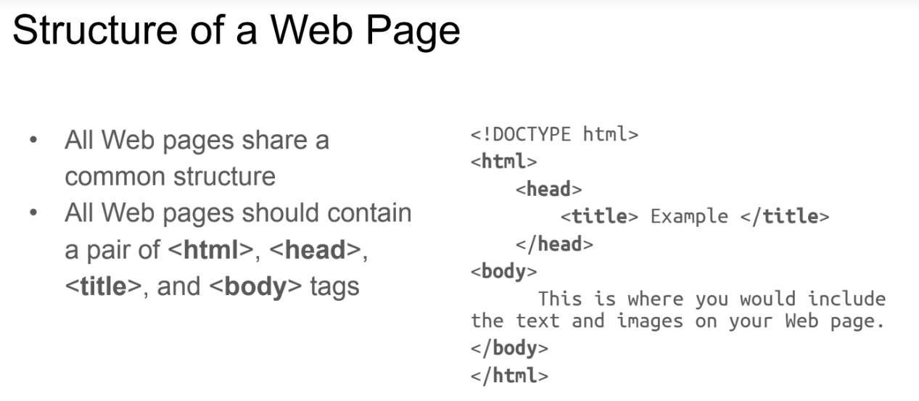

Doctype

● The <!DOCTYPE> declaration must be the very first thing in your HTML

document, before the <html> tag.

● The <!DOCTYPE> declaration is not an HTML tag; it is an instruction to the

web browser about what version of HTML the page is written in.

**so lests talk about some basic tags**, or text formating tags…

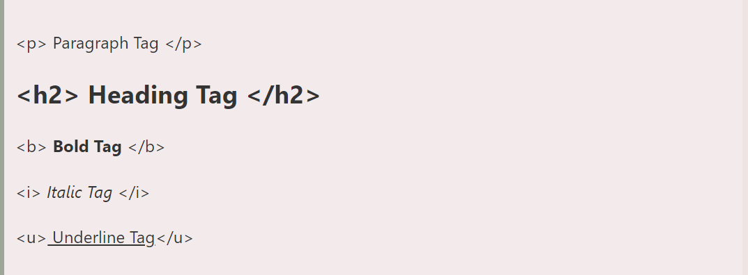

So the the <h1> tag is for the heading ,and there are six sizes <h1> being the biggest and <h6> being the samllest.

**Comments** – to add an comment in html we use this <!-- The comment here -->

**Inserting images** – to insert an image we use the tag <img> and unlike other tags this tag does not hav an close tag ,

* Type <img src = “image.ext”>, where image.ext indicates the location of the image file
* The width=n and height=n attributes can be used to adjust the size of animage+



**Altrnate Text**

* Some browsers don’t support images. In this case, the ALT attribute can be

used to create text that appears instead of the image.

Example:

<img src=“dog.jpg” alt = “Picture of a Dog”>

**Links**

• A link lets you move from one page to another, play movies and sound, send

email, download files, and more....

• A link has three parts: a destination, a label, and a target

• To create a link type

<a href=“page.html”> label </a>



CSS ( Cascading Style Sheets )

Cascading Style Sheet, or CSS. A text file with an extension is a typical CSS file. css and consists of a number of instructions or rules. These guidelines specify how to show in HTML.

HTML and CSS work together to produce beautiful and functional Web sites

● HTML = structure

● CSS = style

There are 3 ways to attach CSS to a page:

1. External Style Sheet: Best used to control styling on multiple pages.

<link rel="stylesheet" type="text/css" media="all" href="css/styles.css" />

2. Internal Style Sheet: Best used to control styling on one page.

<style type=“text/css”> h1 {color: red}

</style> Attaching a Style Sheet

3. Inline Style Sheet*: CSS is not attached in the <header> but is used directly

within HTML tags.

<p style=“color:red”>

Some Text</p>

**To be Continued**

|  |  |  |
| --- | --- | --- |
|  |  |  |
| The End.  Thank you |
|  |